SYSTEM ANALYSIS PROJECT TEAM
TEAM MEMBERS
-Harun Enes Oğuz 9A220011
-Yiğit Güleryüz 9A210028
-Kerem İnan 9A210032
-Can Çoral 9A190036
-Asil Gündüz 9A210088*
-Enes Dikmen 9A210029

PROJECT: BEŞİKTAŞ APP
1.
External Entities:
- Fans
- Team
- The Football Federation
- Government
Processes
- User Registration and Login
- Ticket Purchase
- Match Schedule and Updates
- In-App Payments
- Fan Community and Chat
- Merchandise Store
- Live Match Streaming
Data Stores:
- Revenue Database
- Team Database
- Fan Database

2. THE CONTEXT DIAGRAM
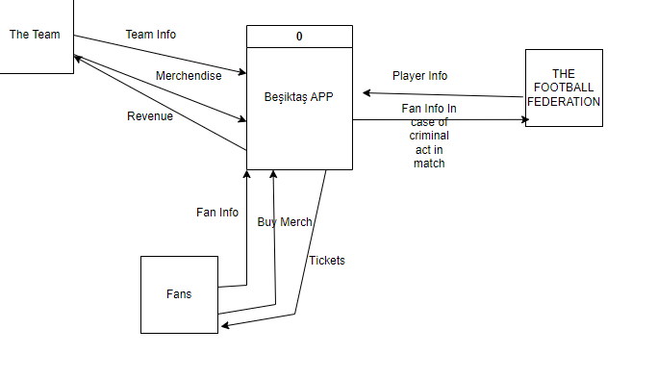
3. DIAGRAM 0
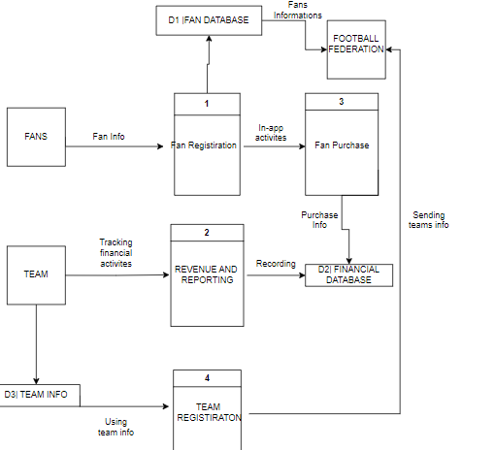

4.CHILD DIAGRAMS

6.Physical Data Flow Diagram of Login Process

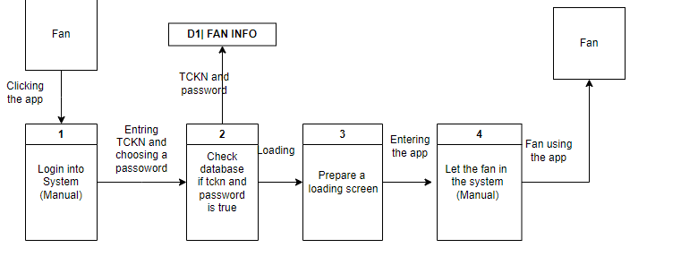

*ASİL GÜNDÜZ DID NOT CONTRIBUTE.

